8/12/2022

COS 207 Assignment

Network Operating System



Khushbeer Singh

Student Id- 00557

Contents

**Task1-Constructing a Ubuntu Linux Network using LAN** 4

(A) Introduction to Ubuntu Linux Networking 4

Installation of Ubuntu Linux 5

(B)Introduction to IPv4 and IPv6 15

Difference between IPv4 and IPv6 16

16

**(**C)Hardware Used In LAN (Include inter-connecting devices such as routers, hubs, switches, NIC, etc.) 16

Routers 17

Hubs 18

Switches 19

NIC (Network Interface Card): 20

Repeaters: 21

(D)Configuring Ubuntu Linux on LAN 22

24

24

24

(E)Assigning IP Address to the LAN 26

List of IP Address used in Ray Hen’s Tale: 26

(F)Testing the Network: 27

(G)Network Diagram for Small Scale Organization 29

**Task2-Operating Environments: Parameters (Budget, Speed, Demand and Privacy)** 30

**Microsoft Windows 10** 30

**Speed:** 30

**Budget:** 30

**Demand:** 30

**Privacy:** 30

**Unix** 31

**Speed:** 31

**Budget:** 31

**Demand:** 31

**Privacy:** 31

32

**OS X Server:** 32

**Speed:** 32

**Budget:** 32

**Demand:** 32

**Privacy:** 32

**Recommendation:** 33

**References:** 34

References 34

# **Task1-Constructing a Ubuntu Linux Network using LAN**

## (A) Introduction to Ubuntu Linux Networking

Ubuntu Linux Networking is an operating system which is basically based on Unix, Linux is a multi-user operating which is developed around in the year 1980’s. Canonical manages Ubuntu, a major Linux distribution and open-source operating system. Canonical provides support and security upgrades for all Ubuntu releases and manages the project's continuous development. Ubuntu comes in several versions, including core, server, and desktop, allowing it to run on a variety of computers. It may be utilized on desktop PCs, servers, supercomputers, cloud computing, and other platforms etc. (Dr Steven Gordon, 16 November 2007)

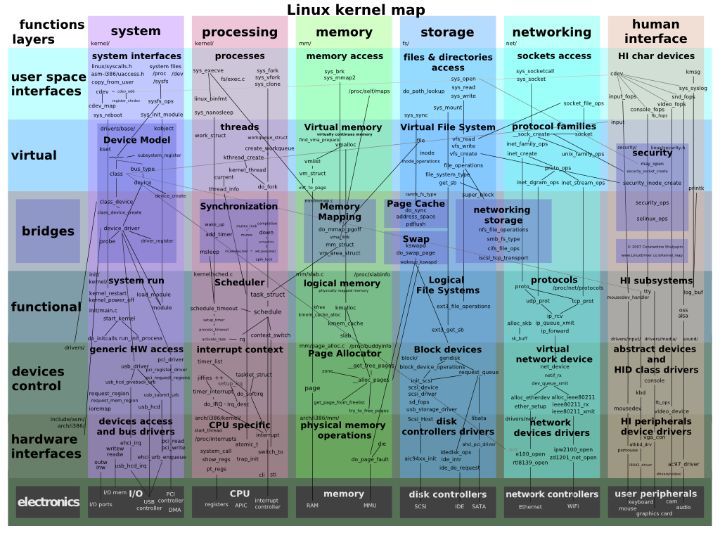

## Installation of Ubuntu Linux

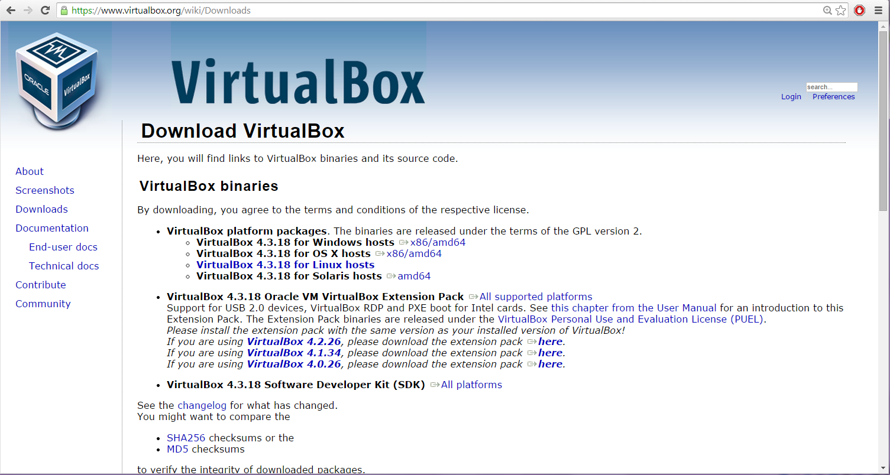In this document the installation of Ubuntu Linux will be shown by utilizing tool called Oracle VM VirtualBox. Oracle VM is a cross-platform virtualization program. It installs on current Intel or AMD-based PCs running Windows, Mac, Linux, or Solaris. VirtualBox can generate and operate a "guest" operating system (virtual machine) in a window of the host operating system. The virtual machine provides a self-contained environment in which to test new software without risking detrimental modifications to the host operating system.

This is the Virtual Box snapshot in which the user willing to use Ubuntu Linux Operating can install the Virtual Box.

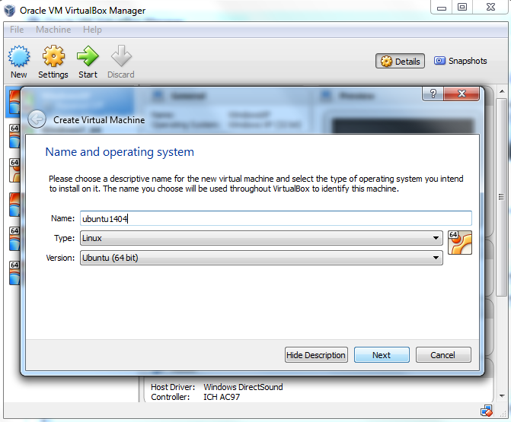

Select a new name for the new virtual machine. Since it is to install Ubuntu 14.04 after executing the process the VirtualBox automatically change its type to Linux and Version of Ubuntu (64bit). These two options are the exactly one that’s need to be put as shown in the above snapshot.

The amount of RAM in host system determines the cache memory size. Suppose the above shown snapshot has 12GB of actual RAM. Acknowledgement research is to reserve as much as for Ubuntu whereas still leaving some memory for Windows host system. For Ubuntu, it chooses 8192 MB. The base memory provided here will serve as the swap partition which VirtualBox creates.

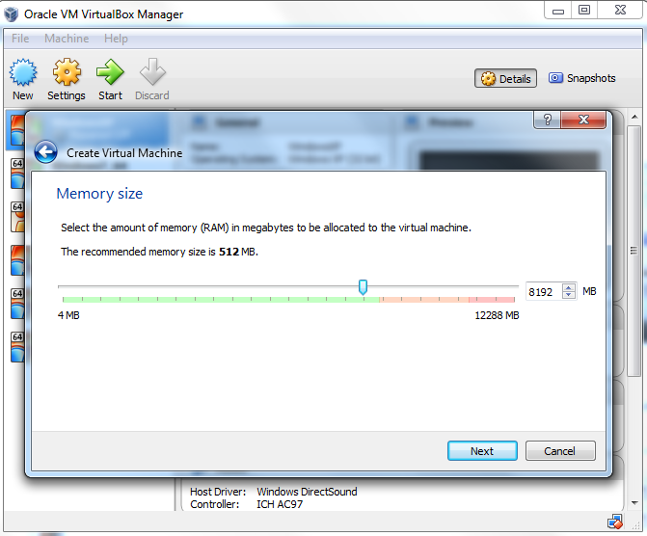

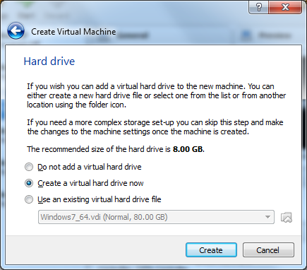

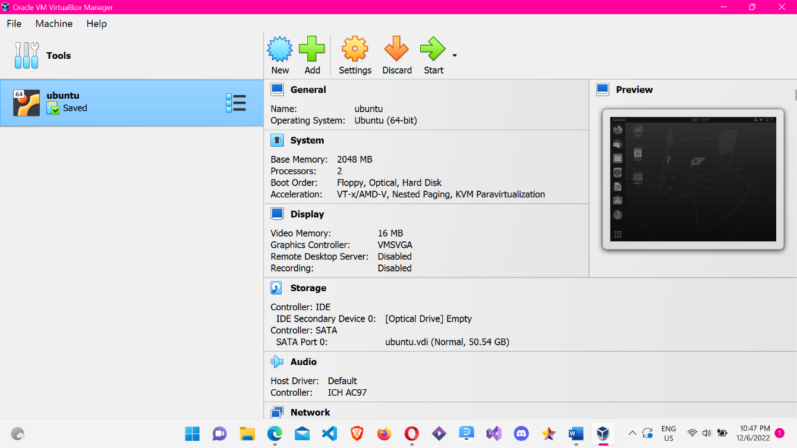To activate select create.

The user can select the start button to execute the virtual machine. To find the .iso file, Select the Add in disc selector after the icon switch on. The user can select the disc on choice, then click the start to execute the operating system.

Now it’s time to proceed with an Ubuntu Linux Operating System. Return to Oracle VM VirtualBox Manager and choose the new Ubuntu virtual machine before pressing the "Start" button. You will now see a "Welcome" screen. Press the "Install Ubuntu" button.

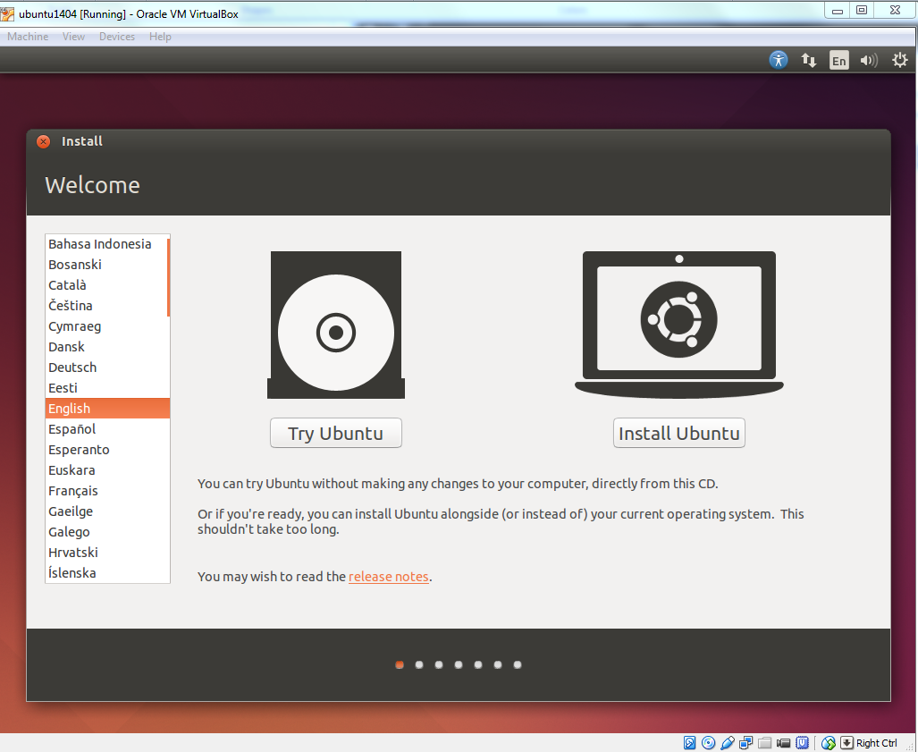

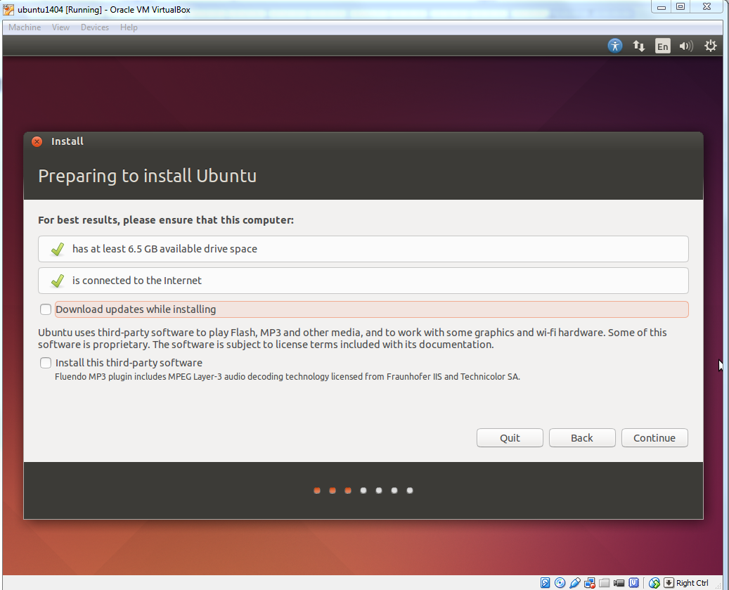

Select Continue as shown in the diagram.

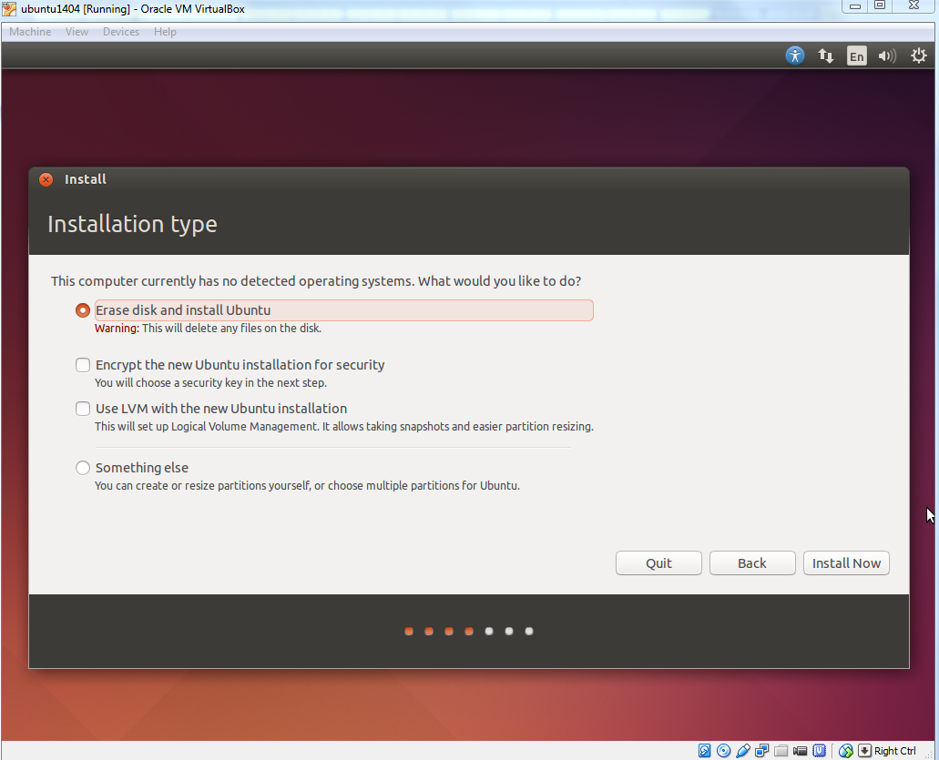

Click the "Install Now" button after making sure the "Erase disk and install Ubuntu" option is checked.

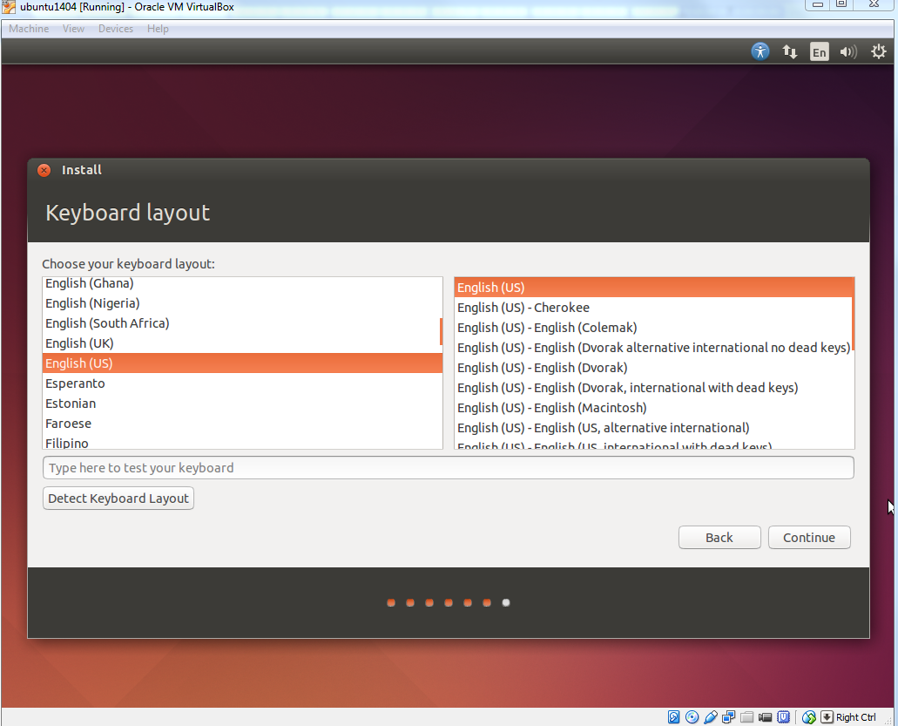The user can choose dominant language as shown in the snapshot.

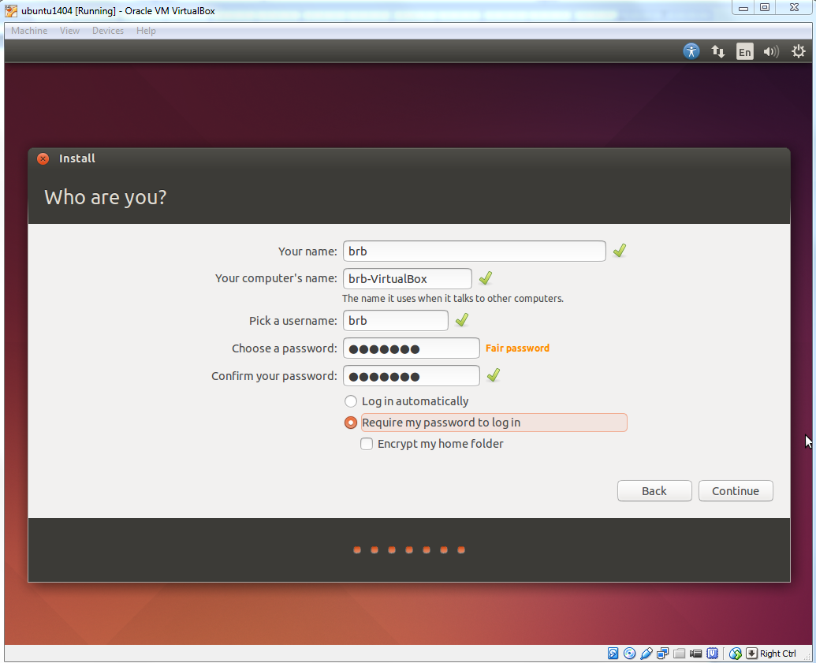

Ubuntu system requests the name of the user, the computer’s name and the fair or strong password is needed for its high security as shown in the snapshot.

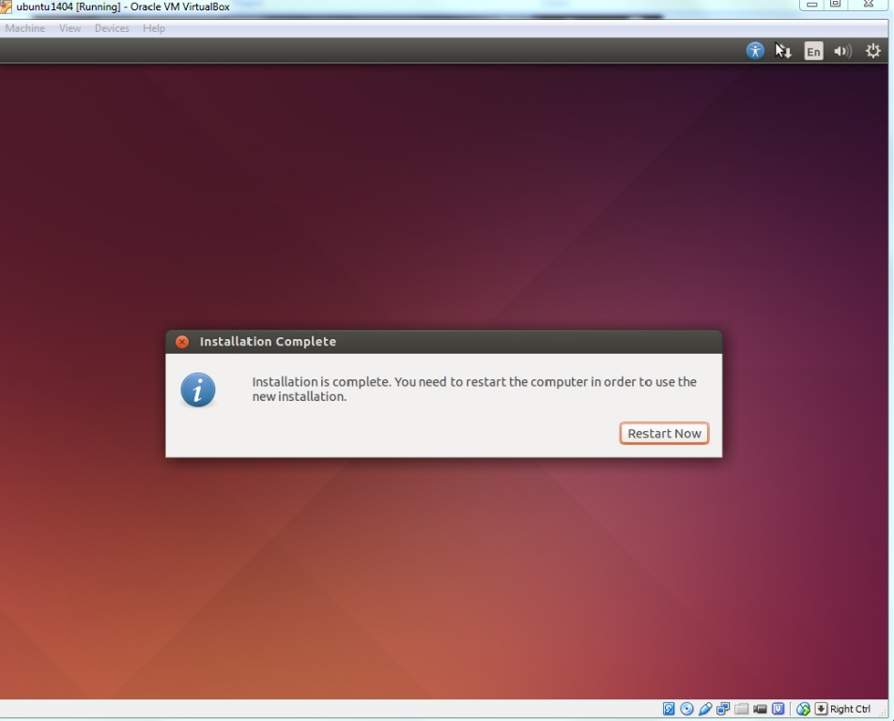

After the installation the system request to restart the system and will ask for the login where the user has to insert the password that has given before.

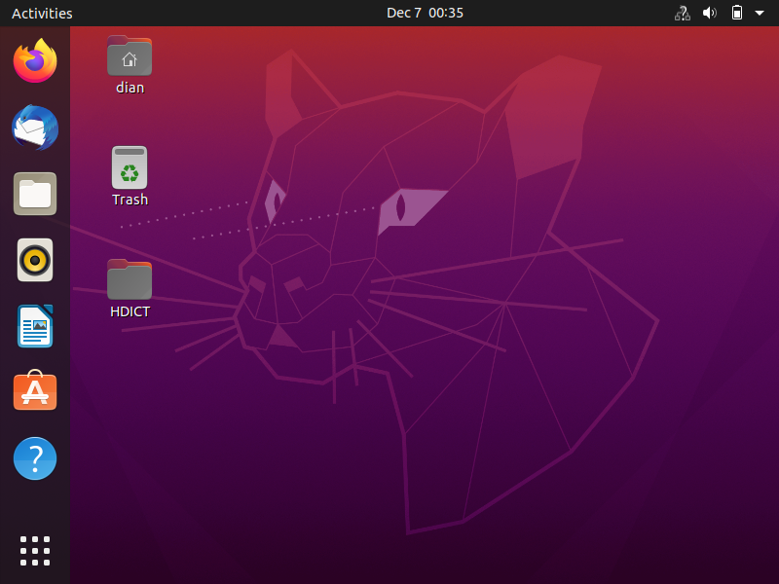

Ubuntu Desktop OS is now available. The desktop screen might be too tiny for you. Not to worry. This issue is readily resolved with "VirtualBox Guest Additions."

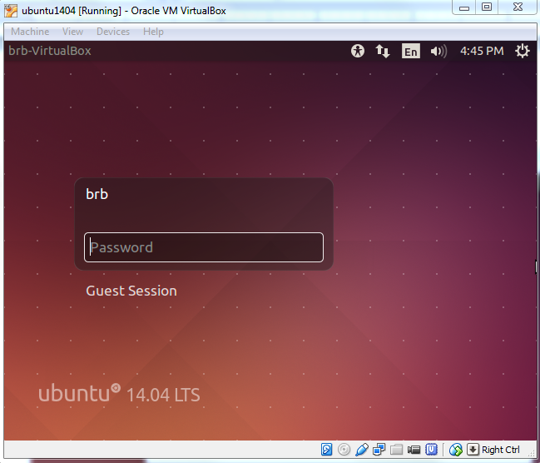

## (B)Introduction to IPv4 and IPv6

**IPv4**

The fourth iteration of the standard for directing Internet traffic and other packet-switched networks, known as Internet Protocol version 4 (IPv4), was released in 1982 by the Internet Engineering Task Force (IETF). Despite having a 32-bit address space, IPv4 is the most used implementation of the protocol. Furthermore, computers and networks do not read IP addresses in this conventional numeric format since they only recognize binary numbers.

A binary number is one that solely employs 1s and 0s.

For example, the binary value for the IP address 66.94.23.12 is...........this binary number is what computers and networking devices really read. Each octet's bits are represented by a number. For binary, each bit on the octet can be either a 1 or a 0.

**IPv6**

The subsequent Internet protocol, known as IPv6, or version 6, will eventually take the place of the existing system, IPv4. When compared to IPv4, IPv6 provides a number of enhancements and simplifications. The main distinction is that IPv6 utilizes 128-bit addresses as opposed to IPv4's 32-bit addresses. Hexadecimal addresses contain both integers and alphabets. So, using this form of address, IP version 6 may generate an astounding 340 undecillion IP addresses. Version 6 appears to be sufficient for the foreseeable future. It is made up of eight groups of sixteen bits, separated by colons. Each hexadecimal character in IPv4 represents four bits. 2023:0DB8:0000:0000: 0000:8A2E: 0370:7334, for example (Olexa, 2022)

### Difference between IPv4 and IPv6

### 

## **(**C)Hardware Used In LAN (Include inter-connecting devices such as routers, hubs, switches, NIC, etc.)

In a building or across buildings, a local area network (LAN) is a collection of computers and computer peripherals (printers, disc storage devices, etc.) connected by high-speed data lines.

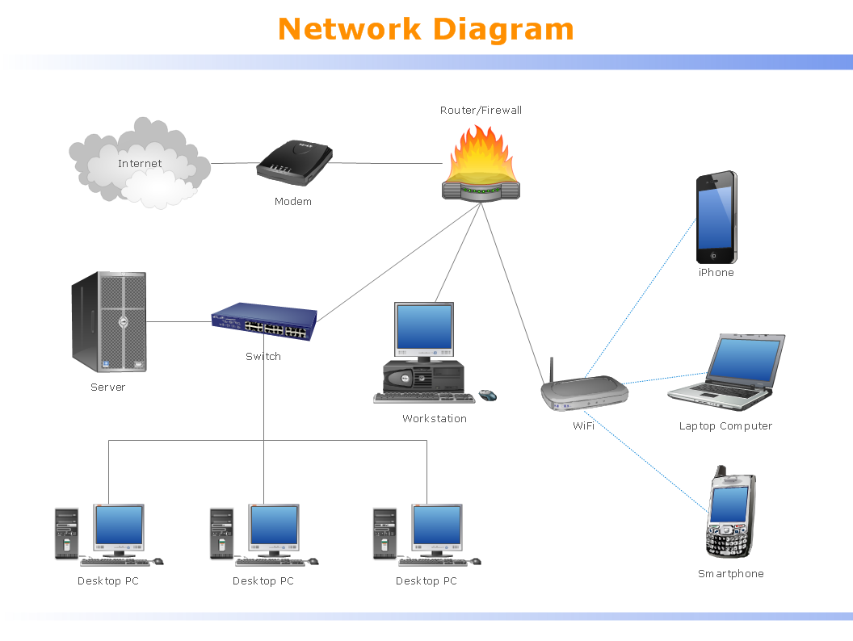

### Routers

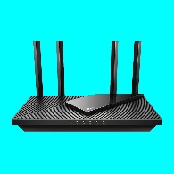

Like any other computer, including a PC, a router is a digital device. Many of the hardware and software parts found in other computers are also included in routers, including:

* CPU (Central Processing Unit)
* RAM (Random Access Memory)
* ROM (Read only Memory)
* Operating System

The Internet's fundamental support system is the router. A router links various network together. This indicates that it has a number of interfaces, each of which is connected to a distinct IP network. A router chooses which interface to utilize to forward an IP packet to its destination when it receives the packet on one interface. (SatyaBahma, 2022)

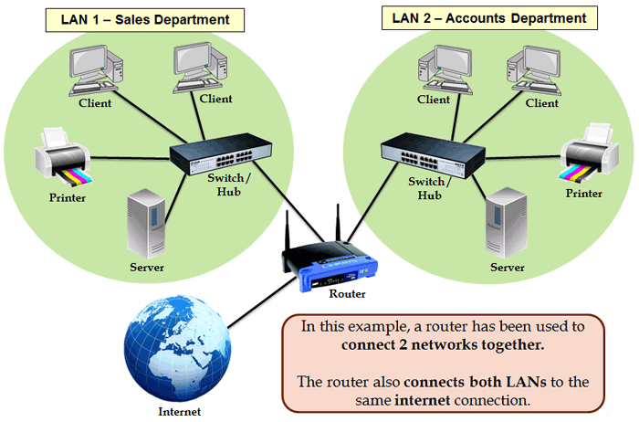

**Router connecting to Network**

### Hubs

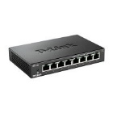

Essentially, a hub is a multiport repeater. A hub joins several wires that come from several branches, like the connector in a star topology that joins various stations. Data packets are delivered to all connected devices since hubs are unable to filter data. Although the term "hub" is ambiguous, it frequently refers to a multiport repeater. It may be used to build a station hierarchy with several levels. (SatyaBahma, 2022)

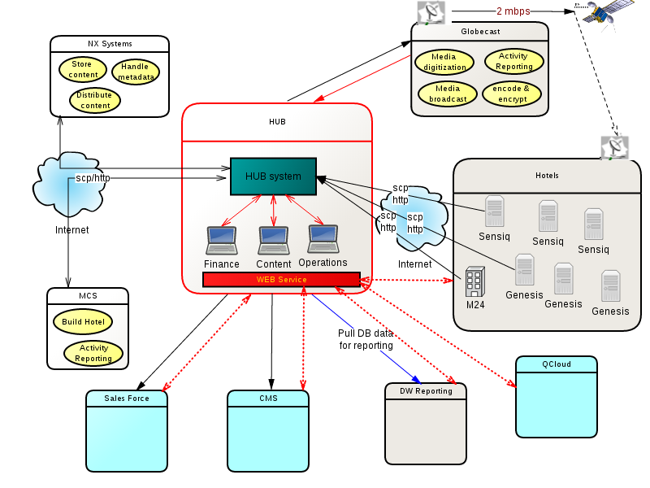

**Hub System**

## Switches

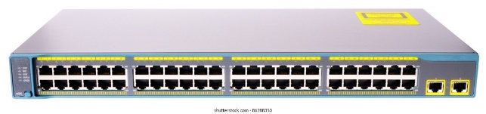

A switch is a multi-port bridge with a buffer and a design that can increase its performance and efficiency (more ports mean less traffic). The data link layer device is the switch. Switches that have the ability to do error checking prior to forwarding data are particularly efficient because they only transfer good packets to the intended port and do not forward packets with errors.

In essence, a switch is a fast bridge with added complexity that enables quicker frame processing. Several crucial functions include:

* Buffers are offered on ports.
* A directory is maintained by Switch: Address and port:
* After reviewing the address, each frame is sent to the appropriate port.
* Cut-through, collision-free, and fully buffered are the three potential forwarding strategies, which are succinctly described here. (SatyaBahma, 2022)

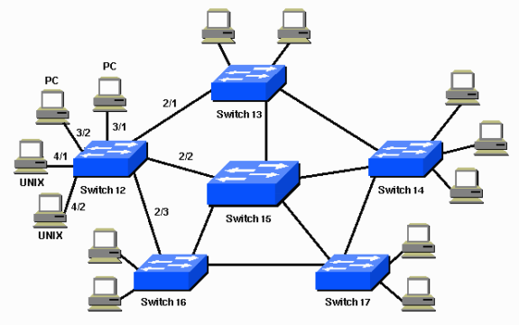

**Switch connecting to PC**

## NIC (Network Interface Card):

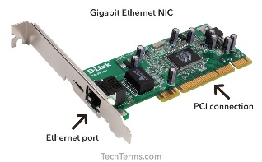

A network interface card (NIC) is used by a computer to connect to a network. The electrical equipment needed to communicate over a wired connection (like Ethernet) or a wireless connection (like WIFI) is contained in the network interface card (NIC).

The electrical component that joins a computer to a computer network, often a LAN, is known as a network interface card (sometimes referred to as a NIC, network card, or network interface controller). It is regarded as hardware for computers. The majority of contemporary computers include internal network interface controllers that are directly integrated into the motherboard as opposed to being given as an external component. (SatyaBahma, 2022)

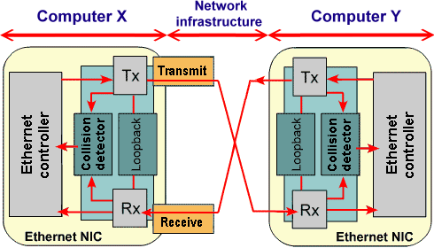

**NIC Diagram**

### Repeaters:

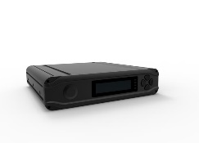

A repeater operates at the physical layer. Its task is to increase the length to which the signal may be broadcast over the same network by regenerating the signal over the same network before the signal becomes too weak or garbled. The fact that repeaters do not enhance the signal is a crucial aspect to keep in mind. When the signal deteriorates, they incrementally replicate it to restore it to its previous strength. The device has two ports.

* A repeater links many LAN segments.
* Every received frame is forwarded by a repeater.
* An amplifier is a regenerator, not a repeater.
* One extended LAN may be built using it. (SatyaBahma, 2022)

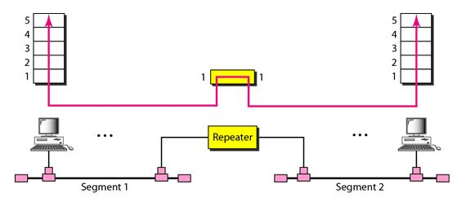

**Repeater Connecting two Segments**

## (D)Configuring Ubuntu Linux on LAN

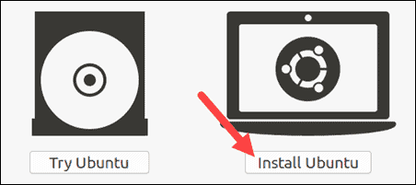

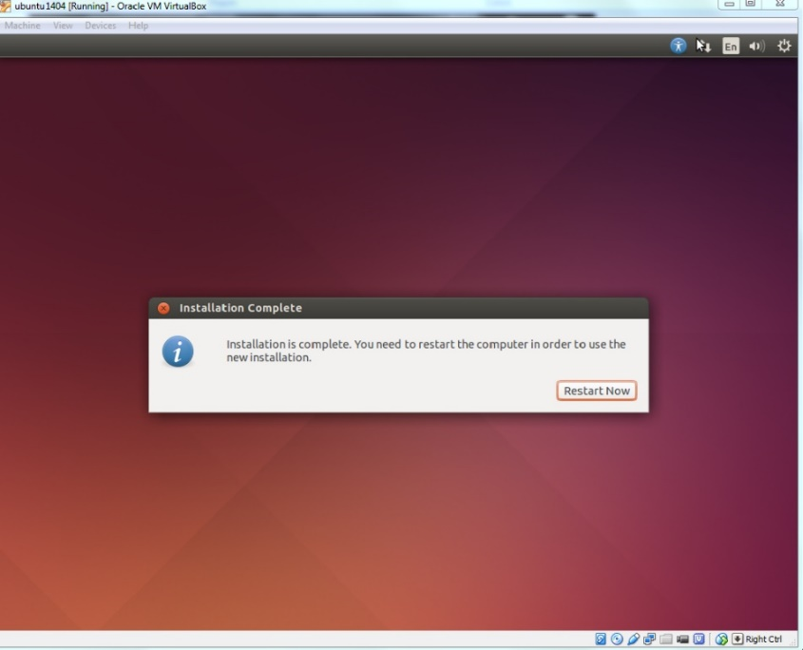

NIC on: /sbin/ifup eth0

NIC on: /sbin/ifdown eth0

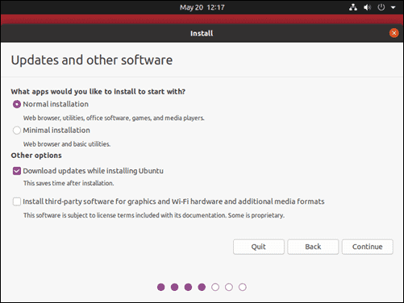

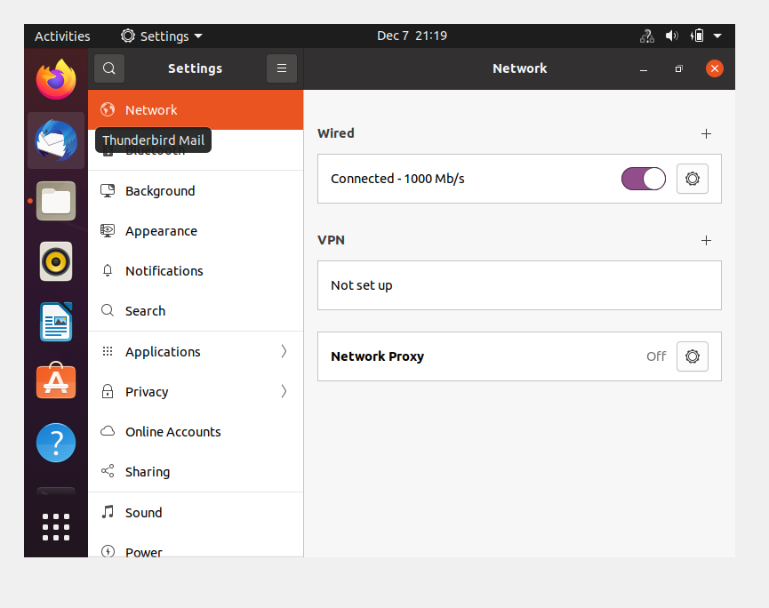

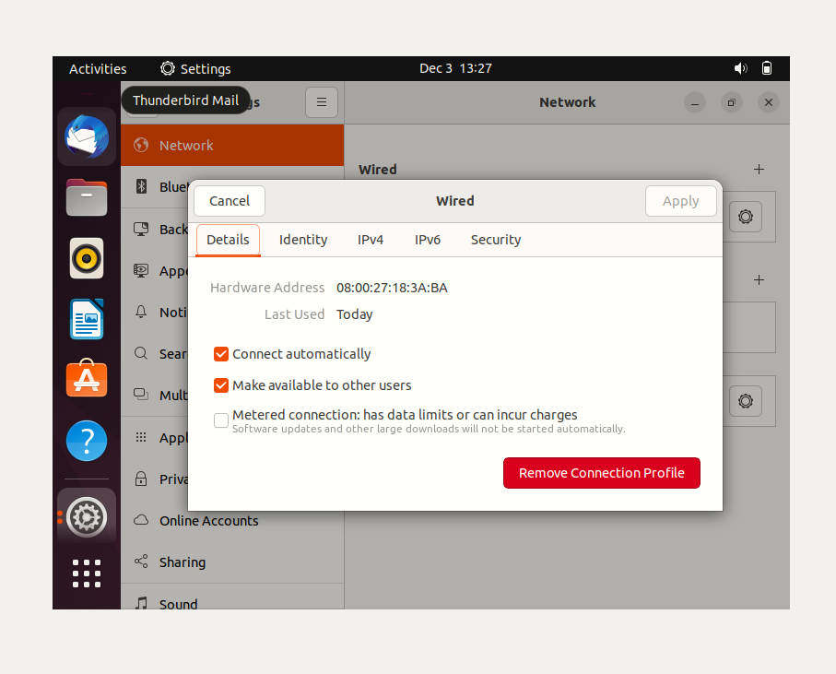

## 

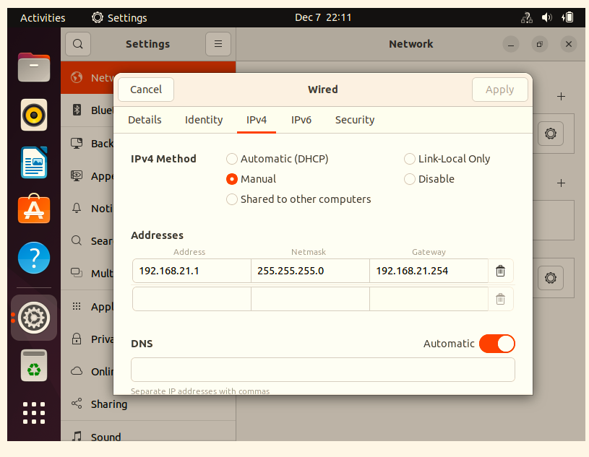

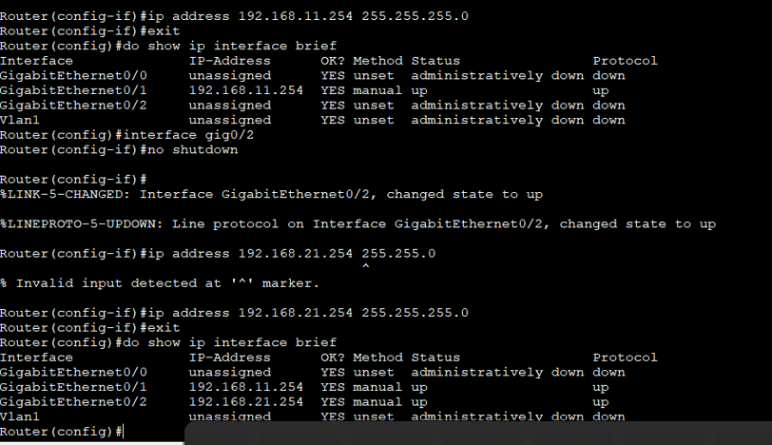

## (E)Assigning IP Address to the LAN

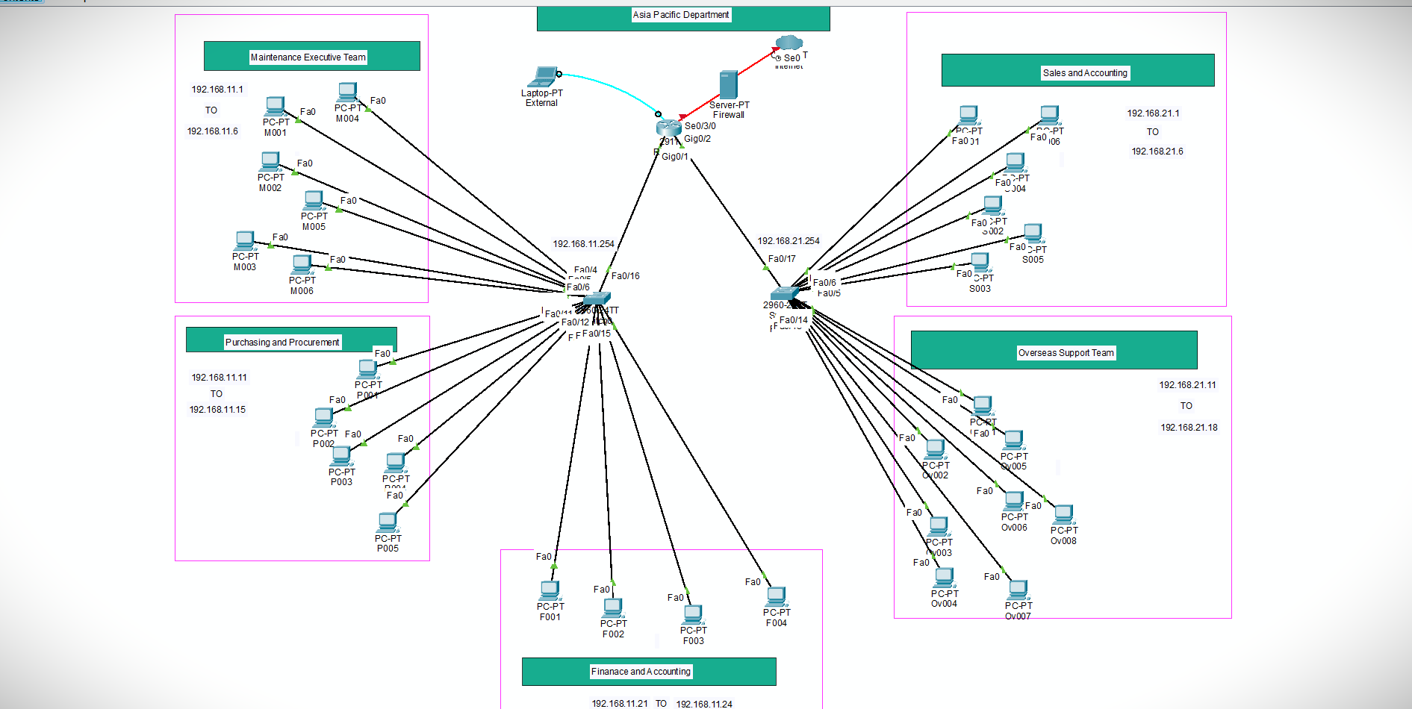

### List of IP Address used in Ray Hen’s Tale:

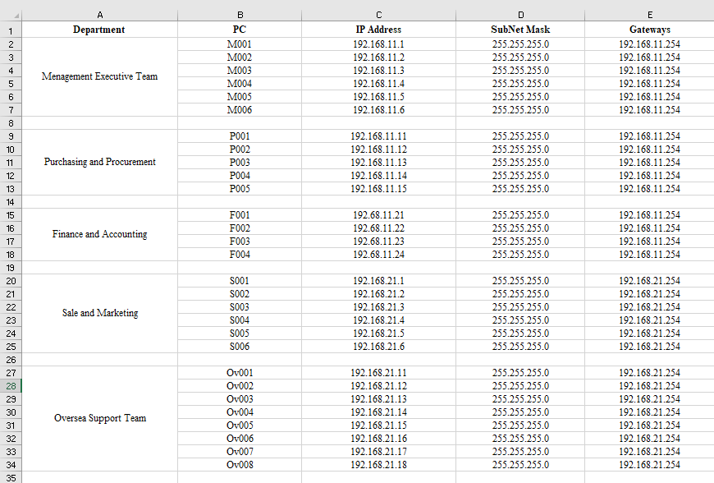

## (F)Testing the Network:

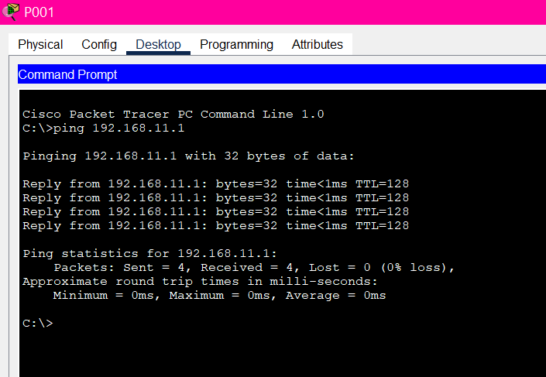

Testing a Network of (P001PC) Purchasing and Procurement by putting an Ip Address of (M001PC) Maintenance Executive Team.

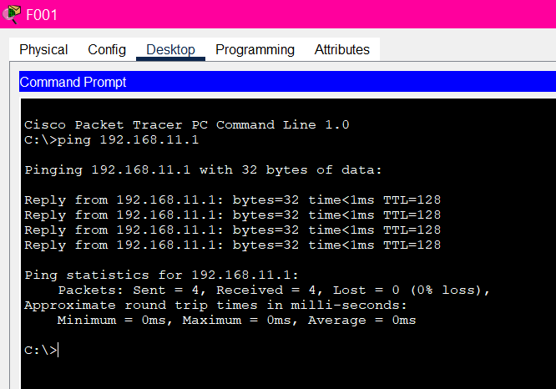

Testing a Network of (F001) Finance and Accounting by putting an Ip Address of (M001) Maintenance Executive Team.

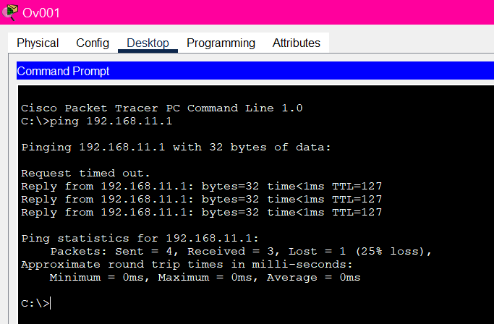Testing a Network of (Ov001) Oversea support Team by putting an Ip Address of (M001) Maintenance Executive Team.

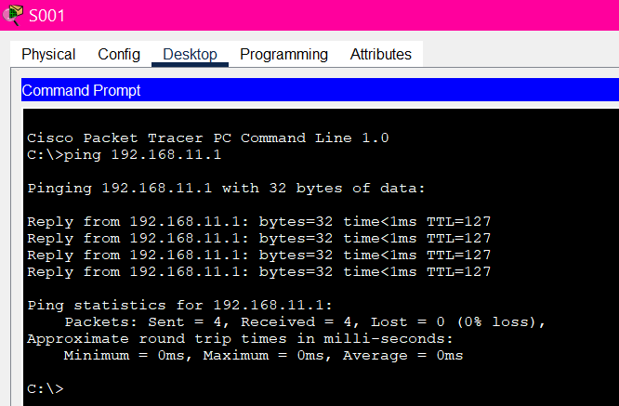Testing a Network of (S001) Marketing Executive Team by putting an Ip Address of (M001) Maintenance Executive Team.

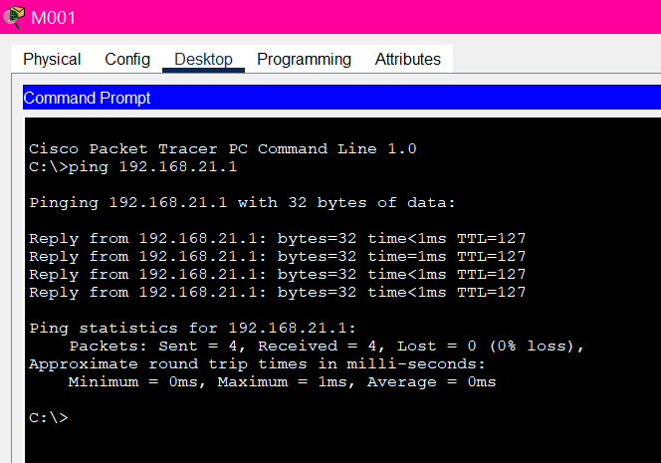

Testing a Network of (M001) Sales and Accounting by putting an Ip Address of (S001) Sales and Accounting.

## (G)Network Diagram for Small Scale Organization



# **Task2-Operating Environments: Parameters (Budget, Speed, Demand and Privacy)**

## **Microsoft Windows 10**

Millions of customers moved to the new operating system when Windows 10 from Microsoft was released because it will provide a more individualized computing experience across a variety of devices.

## **Speed:**

The default architecture of Windows 10 makes it speedier than its predecessors. Compared to Windows 8 and prior versions, the startup and shutdown times are significantly shorter. By turning off pointless launch programs and getting rid of bloatware, the booting process may be sped up.

## **Budget:**

The home windows 10 agency edition is a wise choice for small and midsized businesses. Depending on the license you buy, the total cost of this edition is roughly $7 or $12 per user/month, same like the other Office 365 subscriptions. (Windows, n.d.).

## **Demand:**

Windows offers two different kinds of Features:

* FODs without satellite packages are unified FODs that contain all language resources in a single package. One.cab file is used to distribute these FODs.
* FODs with satellite packages: FODs that are language-neutral but contain separate packages for language and/or architectural resources (satellites).

## **Privacy:**

The security of the system depends not only on the features of security models and designs but also on how these models and designs are put into practice. In order to describe software security, this article will focus on attacks, defenses, and their formal elements. (Rahman, 2022)

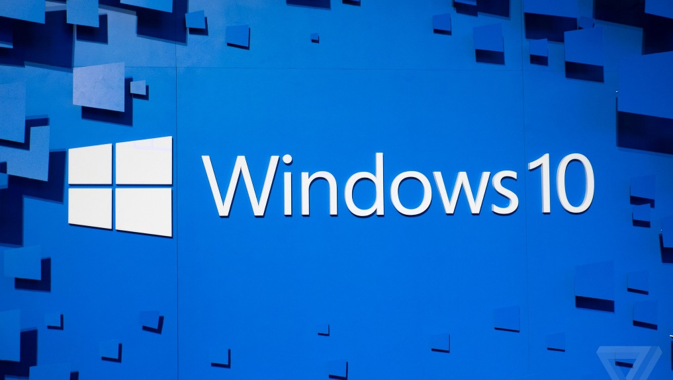

## **Unix**

A group of applications known as the Unix operating system serve as a conduit between the user and the machine.

## **Speed:**

The named pipe was the quickest IPC technique with a block size of 100 bytes, while the UNIX socket was the slowest. The UNIX socket sent at 245 Megabits/s whereas the named pipe transmitted at 318 Megabits/s. The anonymous pipe had a transmission speed of 9,039 Megabits/s compared to the UNIX socket's 41,334 Megabits/s.

## **Budget:**

One 650MHz CPU, two 18GB hard drives, and 512MB of memory are included in the base price of $4,795 for the Unix/RISC 2405 server. Two 650MHz CPUs, 4GB of memory, and 72GB of disk space are included in the 5405, which has a starting price of $29,026.

## **Demand:**

More than any other operating system in history, the Unix operating system has fundamentally influenced operating system architecture during the past 30 years. It offered the first widely dispersed multiuser, multitasking operating environment in history, and it has since given rise to dozens of variants.

## **Privacy:**

However, user error still has the ability to make it vulnerable to viruses Operating systems built on UNIX have always been safer than Windows. My justification is straightforward: Windows exposes far too many important places to possible issues. (Anon., 2022)

## Architecture of Unix | Design and Main Components with Diagram

## **OS X Server:**

With its acclaimed Mac OS X interface and powerful yet user-friendly programs and utilities, Mac OS X Server simplifies your administrative responsibilities.

## **Speed:**

OS X Server is known for its processor quality using dual core processing unit. Now a day, A15 bionic chip is the fastest processor in the OS X server bringing its hertz from 1 t o120 hertz regarding the necessity of the client and the beloved OS environment user.

## **Budget:**

Description on OS X Server it’s a quite bit high on its price as compare to Unix Operating System and Microsoft Window. According to the client connected to OS X Server has to pay at least $ 50 /per month for its high available security provided by the server.

## **Demand:**

The Demand of OS X server is not from today as it demands from a decades ago. The Demand is at its peak, growth has been analyzed utmost 200% per year as correlate a decade ago.

## **Privacy:**

Privacy as an operating system service enables a single point of privacy scrubbing2 and privacy policy enforcement. Having a central site for policy implementation and privacy scrubbing considerably simplifies privacy administration.

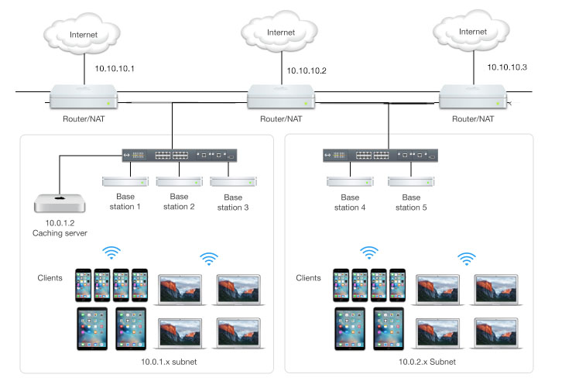

## **Recommendation:**

The Difficulty of Creating an Operating System It will be extremely difficult to design a well functional, safe, and evolving OS based on today's OS (operating system) standards and the requirements of apps, security, and legislation. This might explain why there are only three main operating systems in the world today: Linux, Windows, and macOS. These are the folks who value security, speed, cost, and simplicity of maintenance. At the end I would like to recommend the Linux Operating System for the client rather than OS and Window Operating System.

# **References:**

# References

Anon., 2022. *HP releases budget-minded Unix servers.* [Online]   
Available at: https://www.cnet.com/tech/tech-industry/hp-releases-budget-minded-unix-servers/

Dr Steven Gordon, 16 November 2007. *ITS 332 Networking Lab.* [Online]   
Available at: https://sandilands.info/sgordon/teaching/its332y07s2/protected/ITS332Y07S2H02-Ubuntu.pdf  
[Accessed 12 8 2022].

Olexa, R., 2022. [Online]   
Available at: Networking Components and  
[Accessed 2004].

Rahman, M. M., 2022. *A Comparison of Major Operating Systems: Linux, Windows, macOS.* [Online]   
Available at: https://www.researchgate.net/publication/361474320_A_Comparison_of_Major_Operating_Systems_Linux_Windows_macOS  
[Accessed 22 June 2022].

SatyaBahma, 2022. *NETWORK & APPLICATION LAYER.* [Online]   
Available at: https://www.sathyabama.ac.in/sites/default/files/course-material/2020-10/unit5_2.pdf  
[Accessed 12 8 2022].